What is included in the output of the following code?

Var base = …

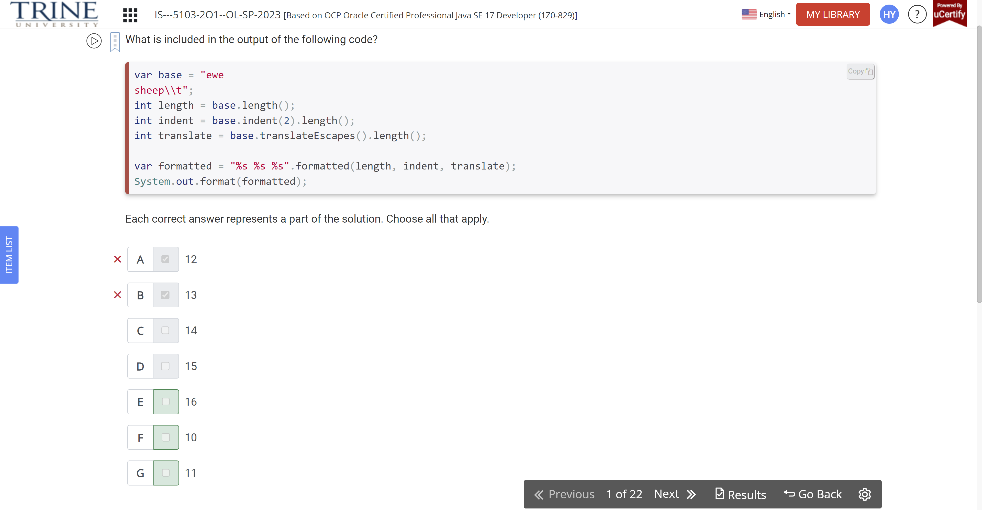

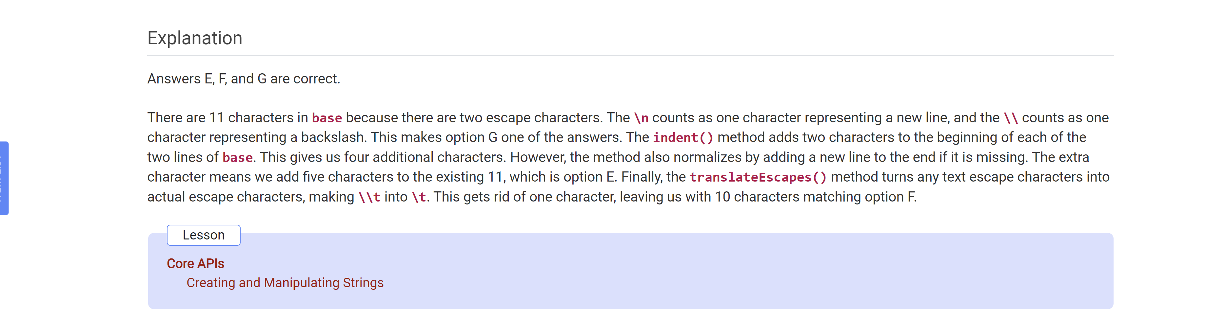

What is the output of the following code?

Var numbers = …

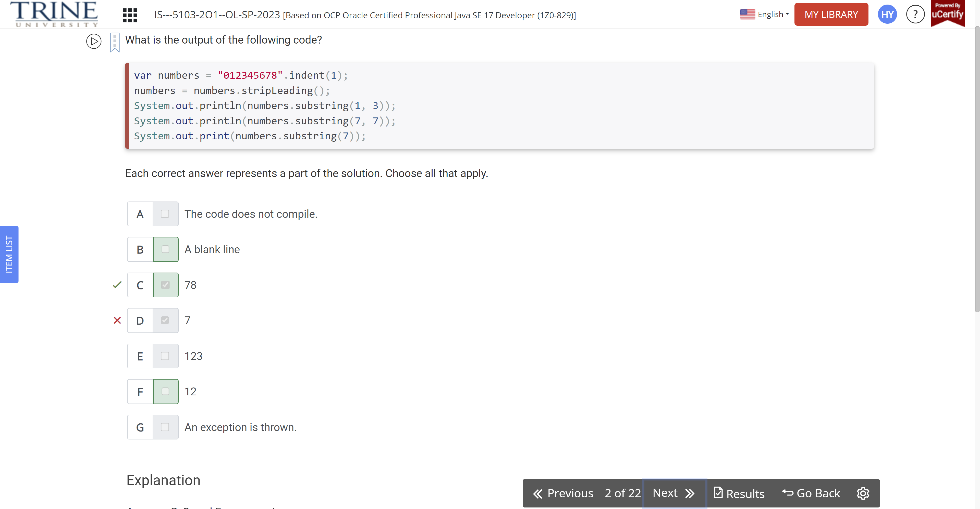

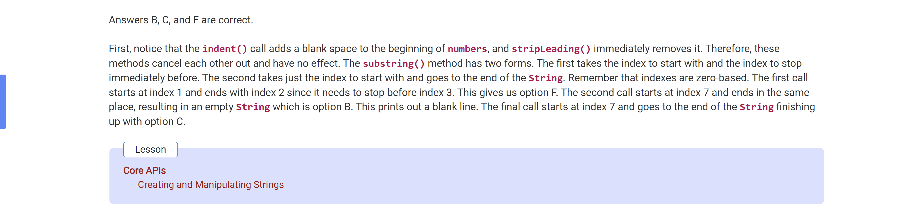

Note that march 13, 2022 is …

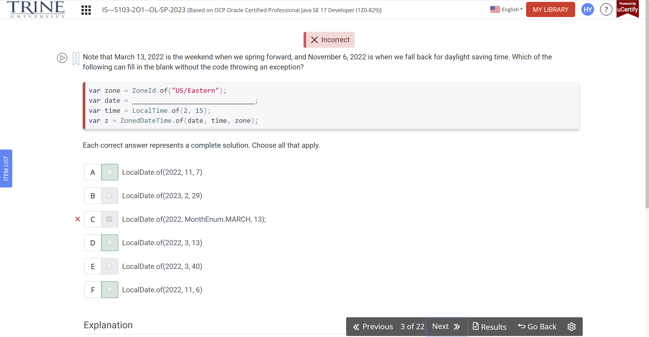

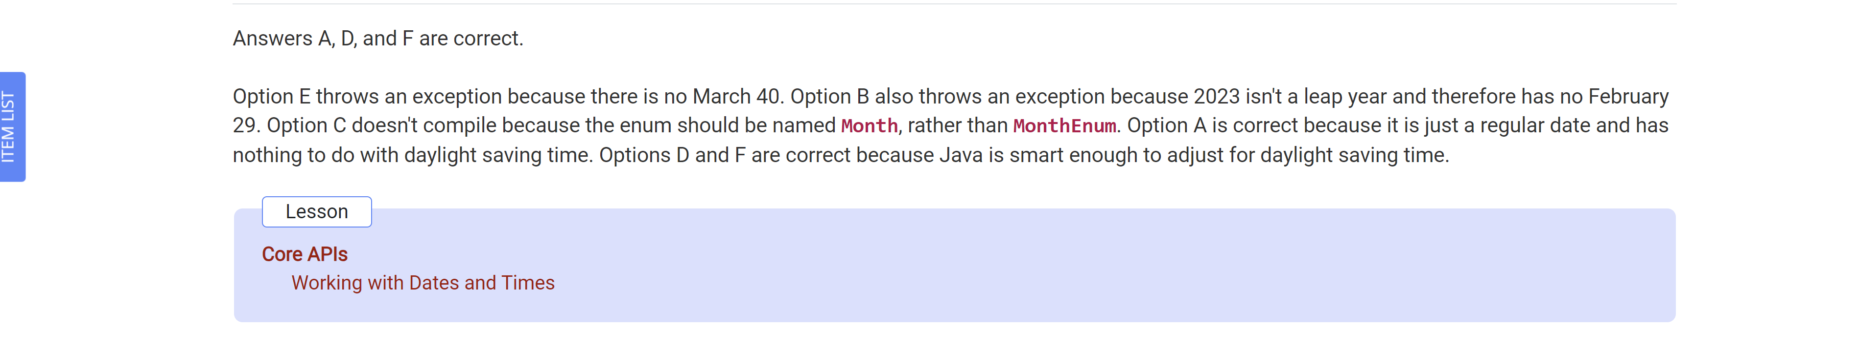

What is the output of the following code?

Var date = LocalDate.of…

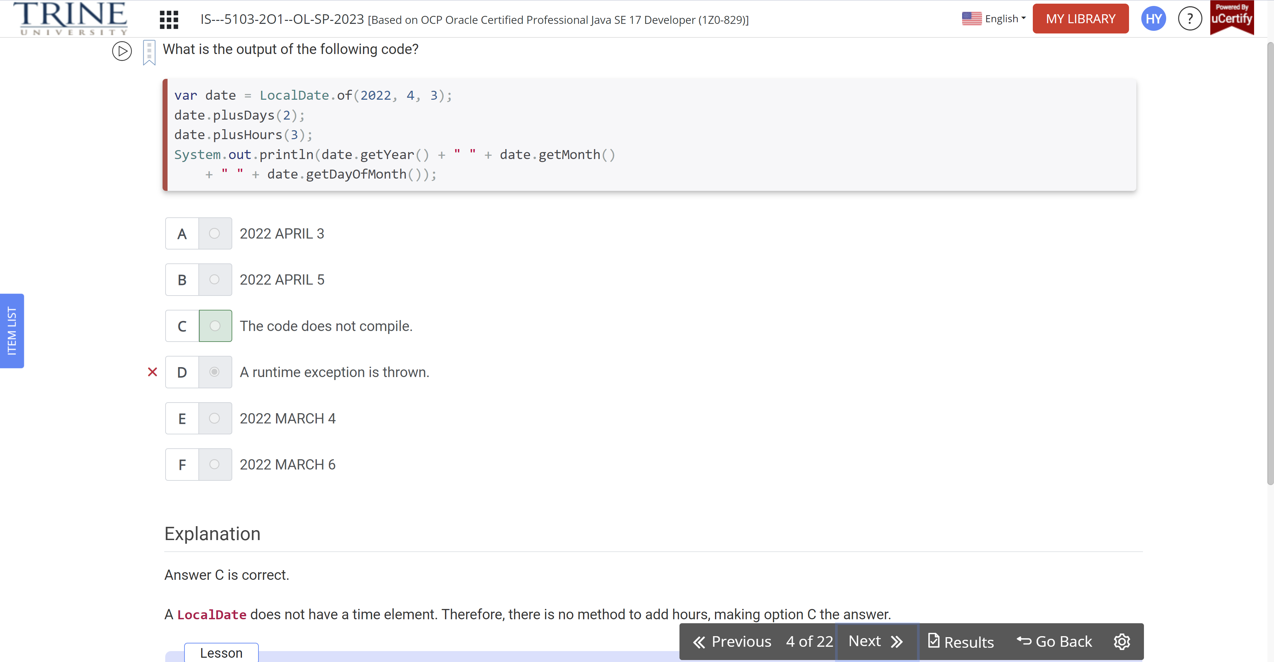

What is the output of the following code?

Public class Fish…

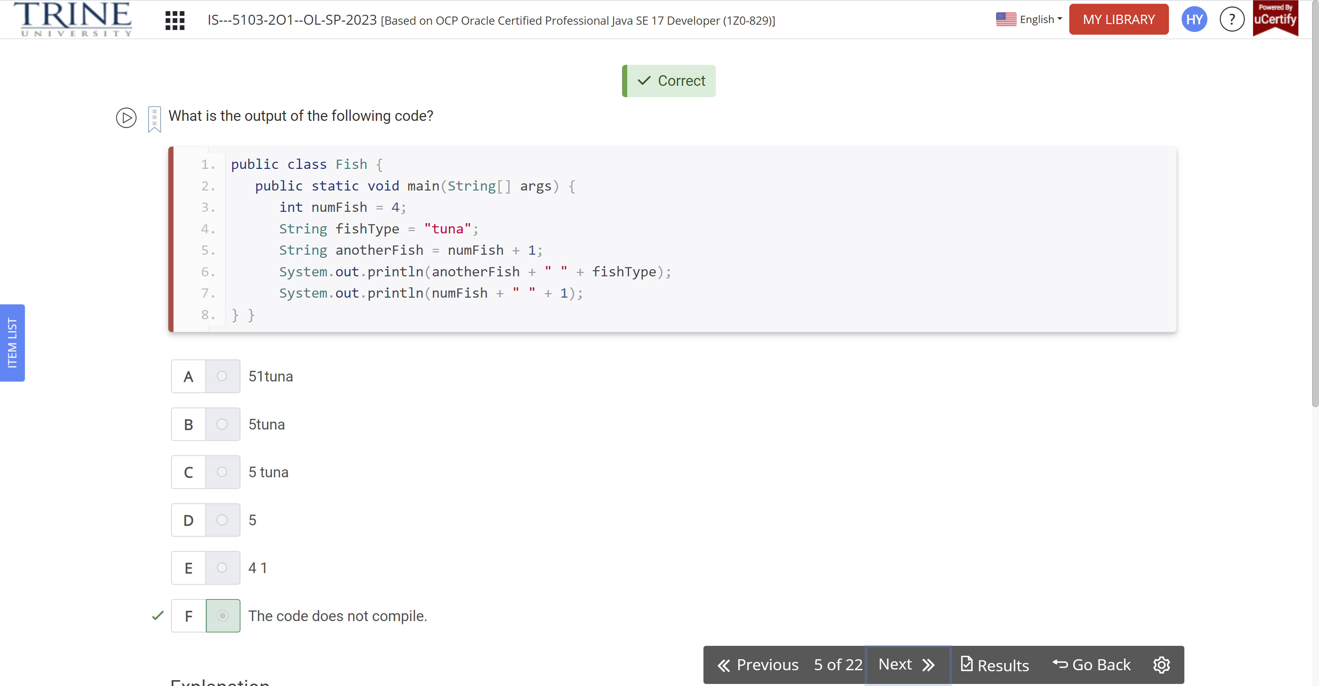

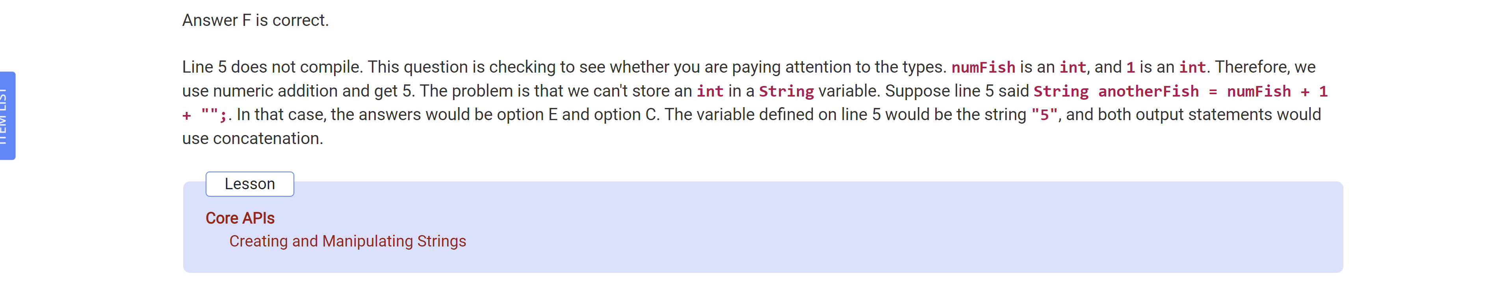

Which of these array declarations are not legal?

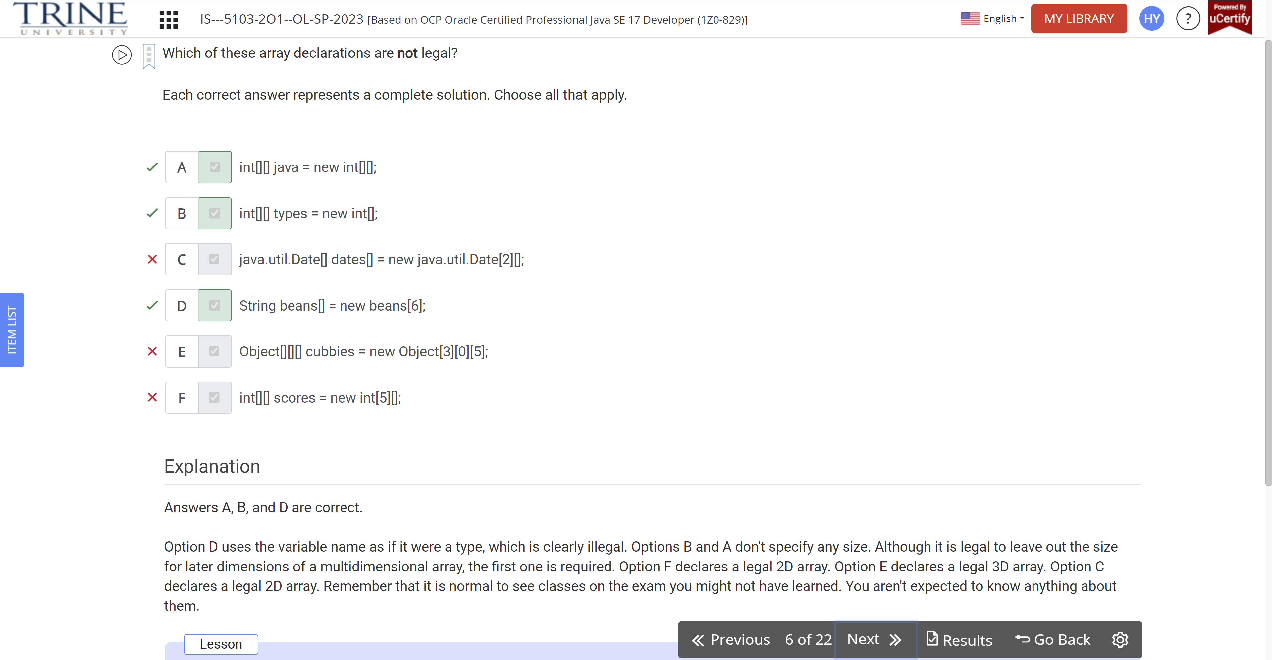

Which of the following return 5 when run independently?

Var string = “12345”;

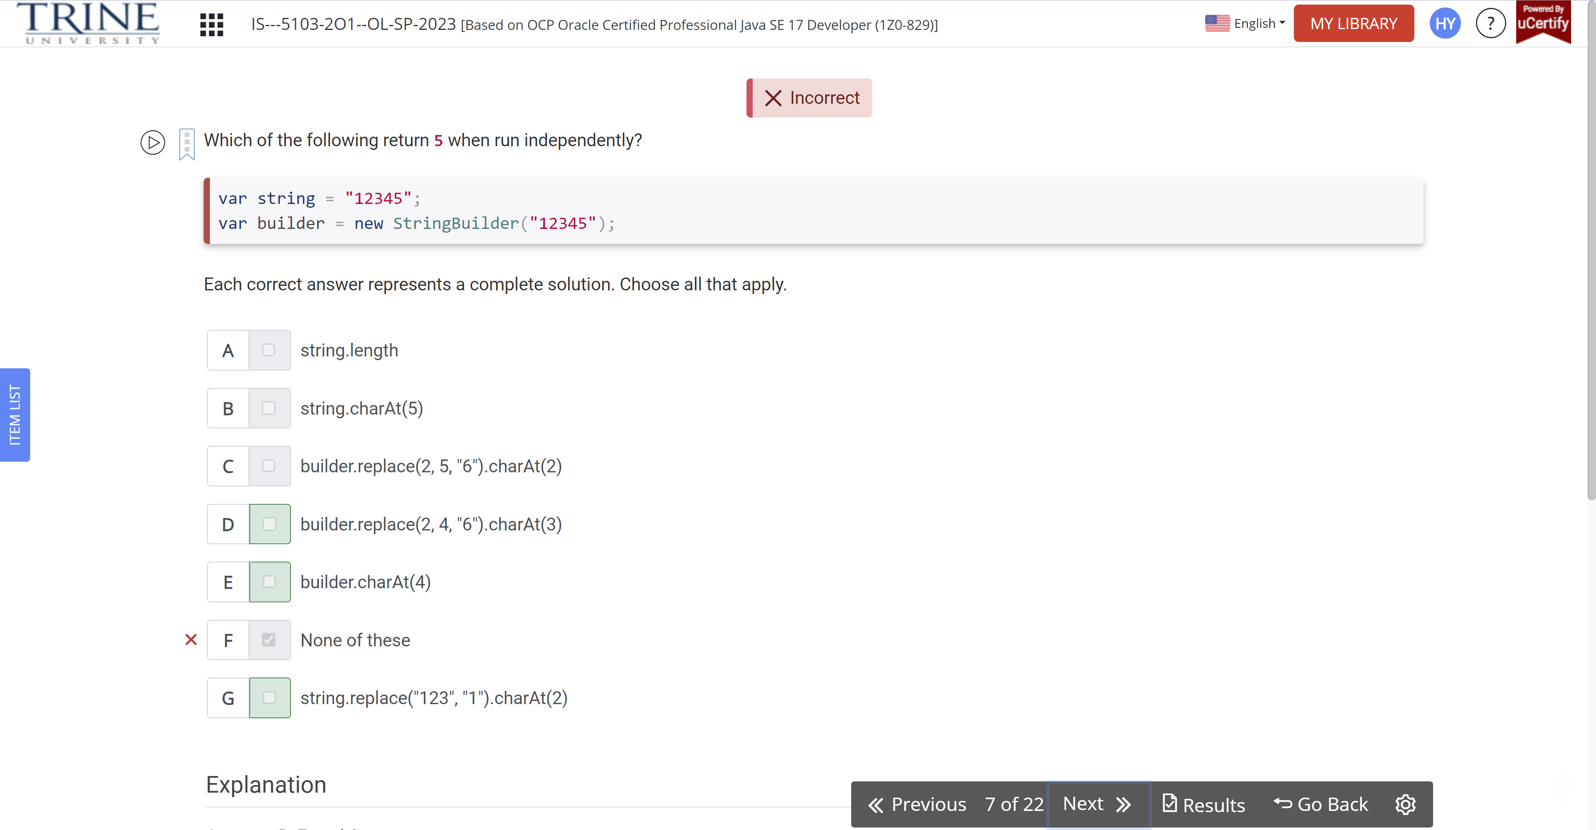

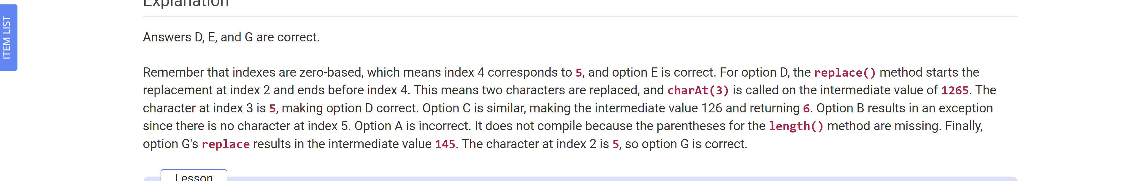

How many of these lines contain a compiler error

Int one = Math.min

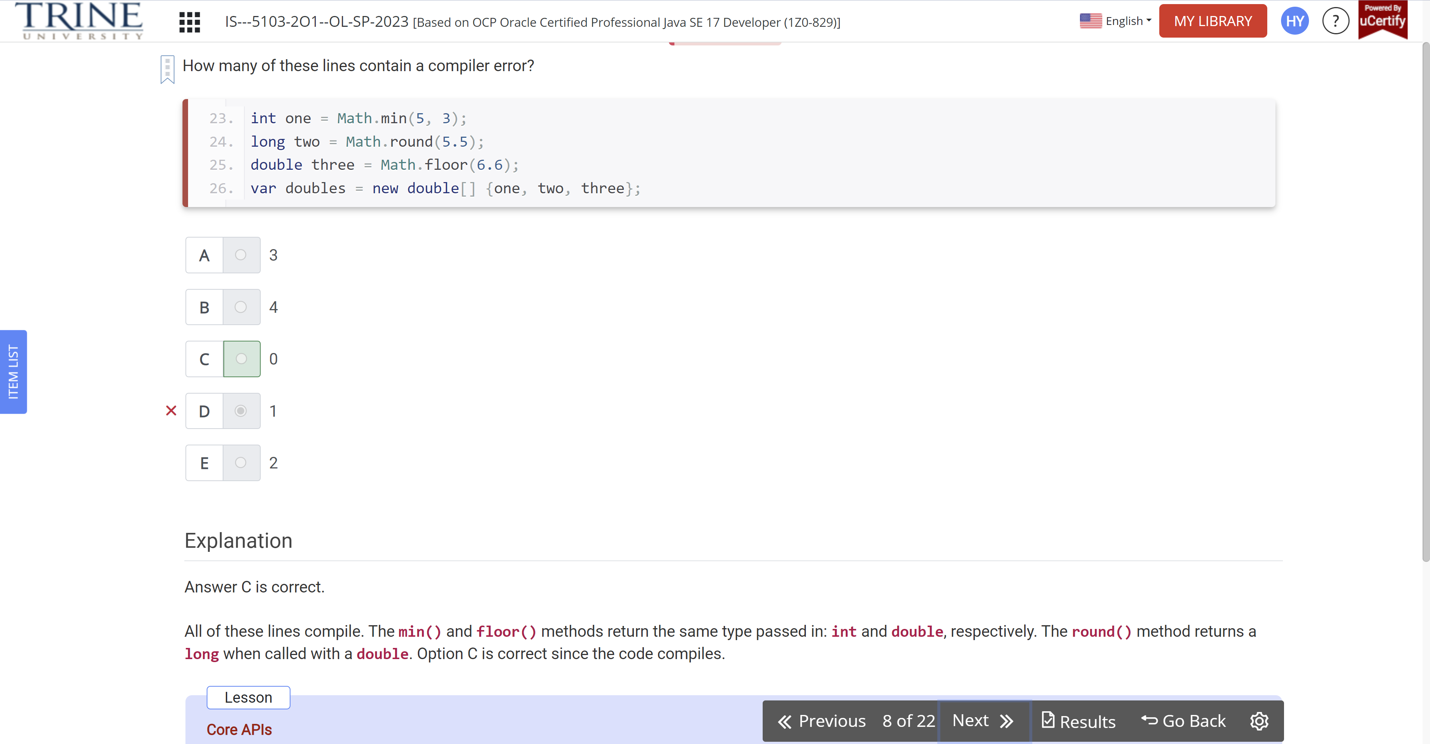

What is the result of the following code?

Var sb = new …

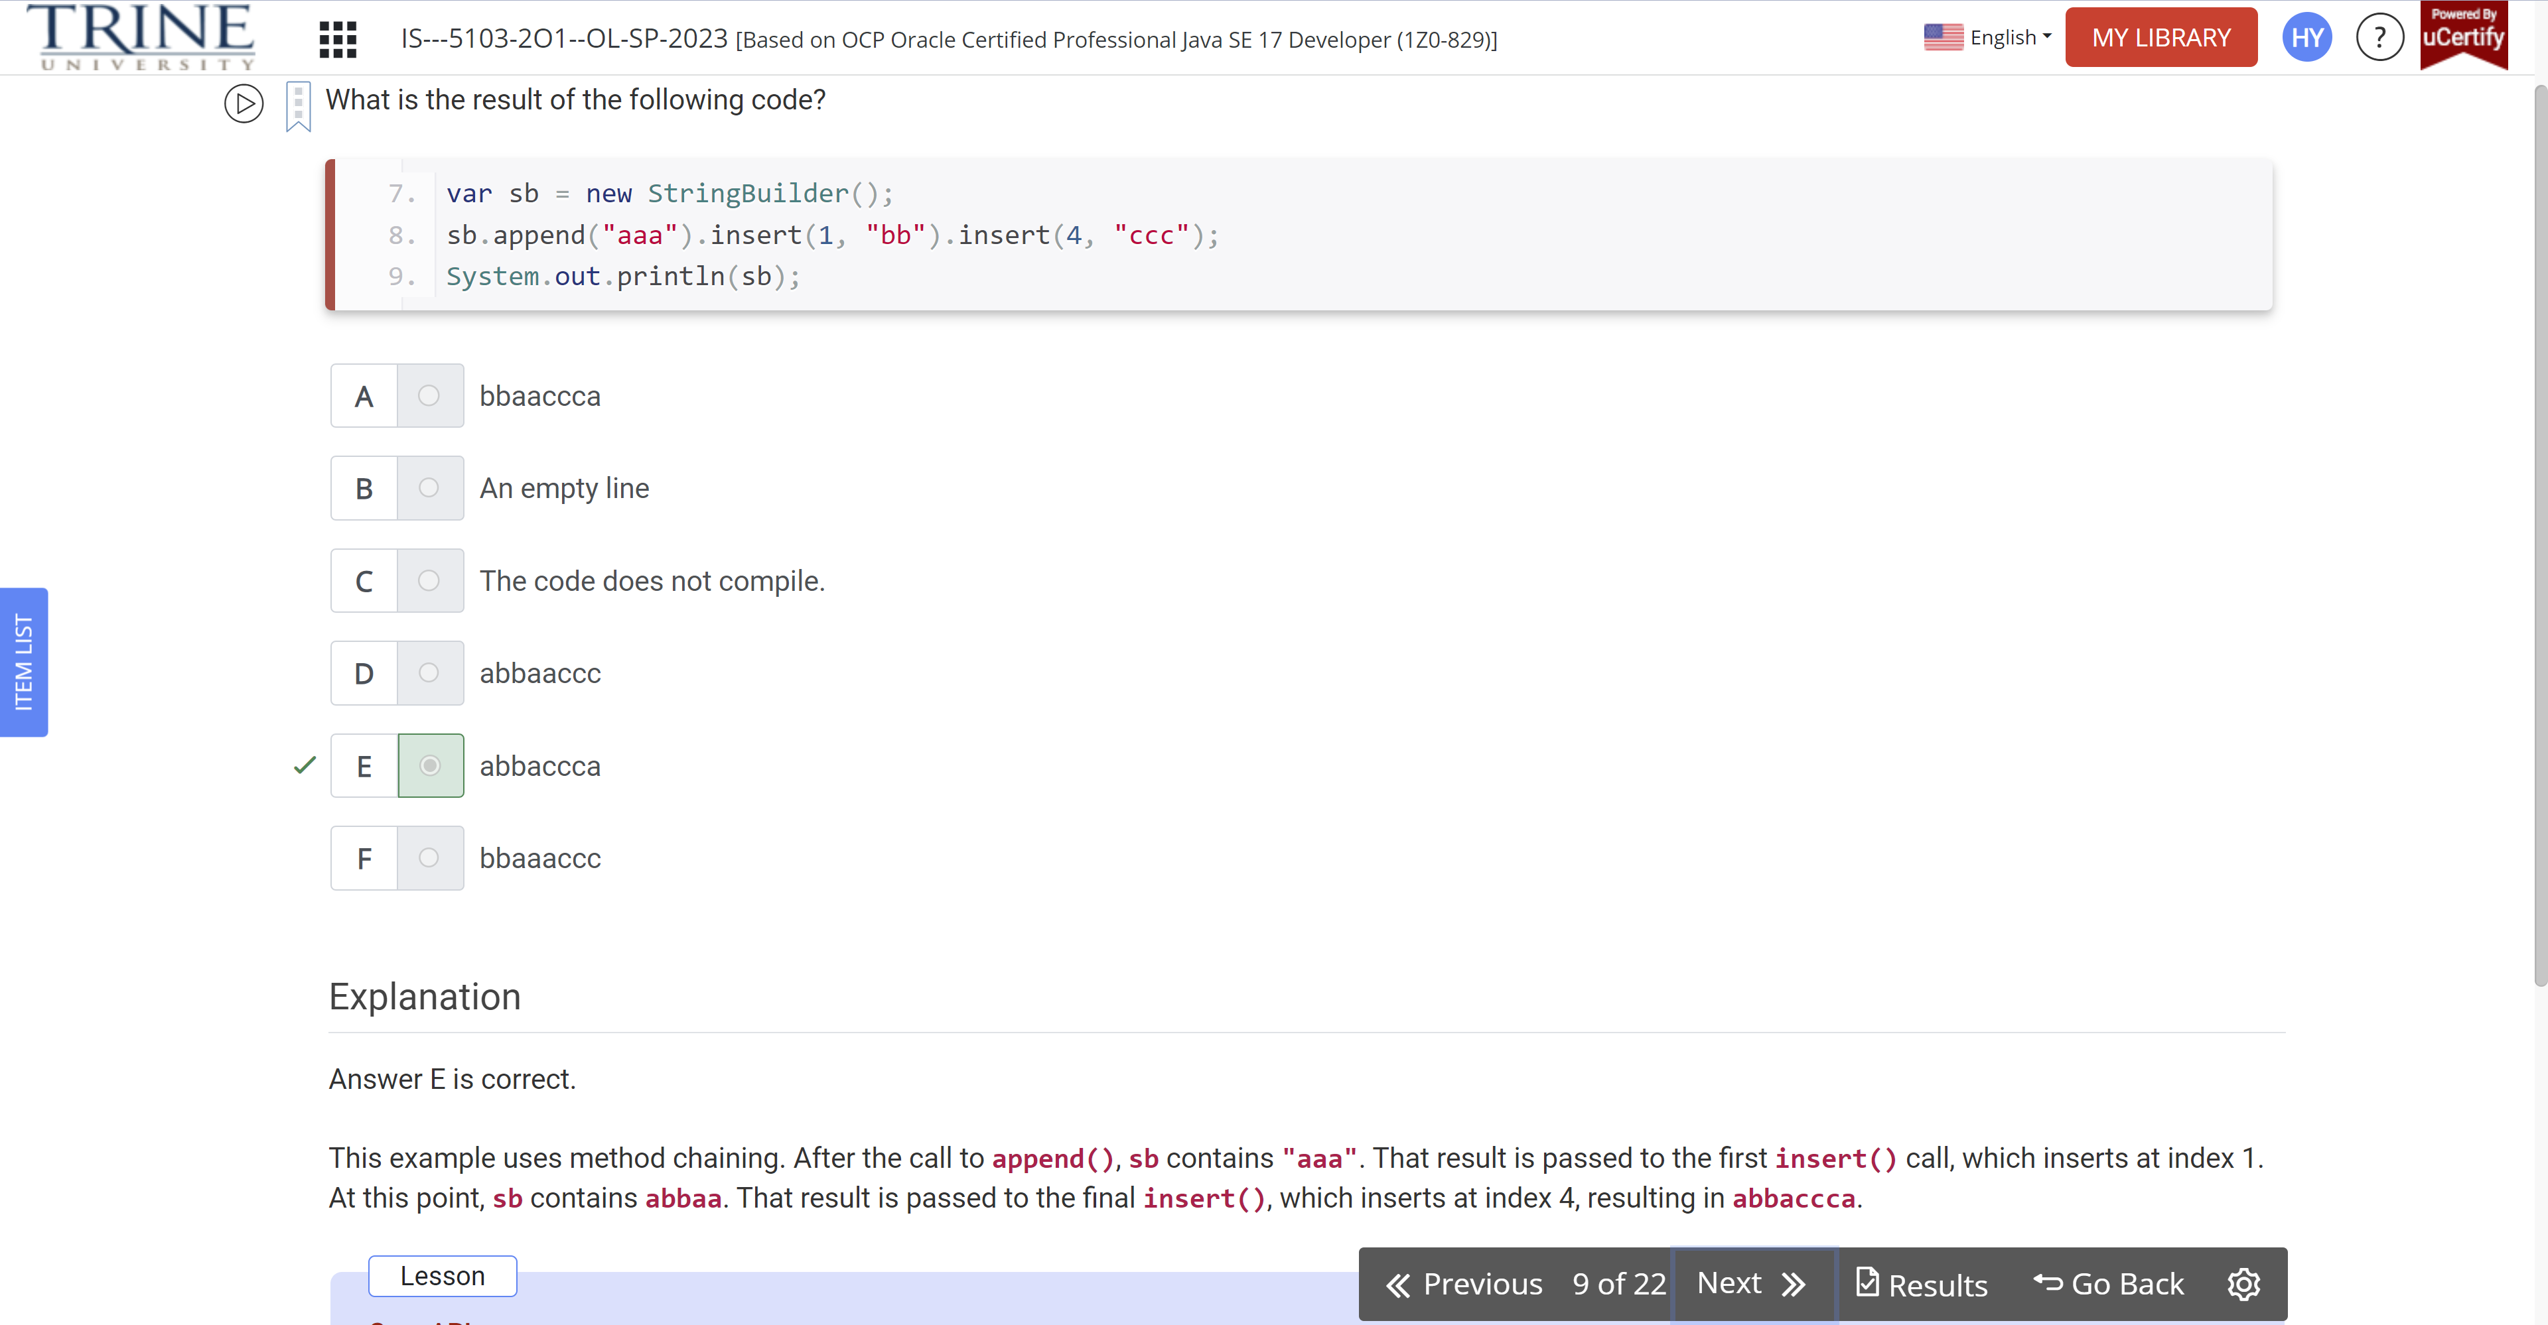

Note that March 13, 2022 is the weekend that clocks spring ..

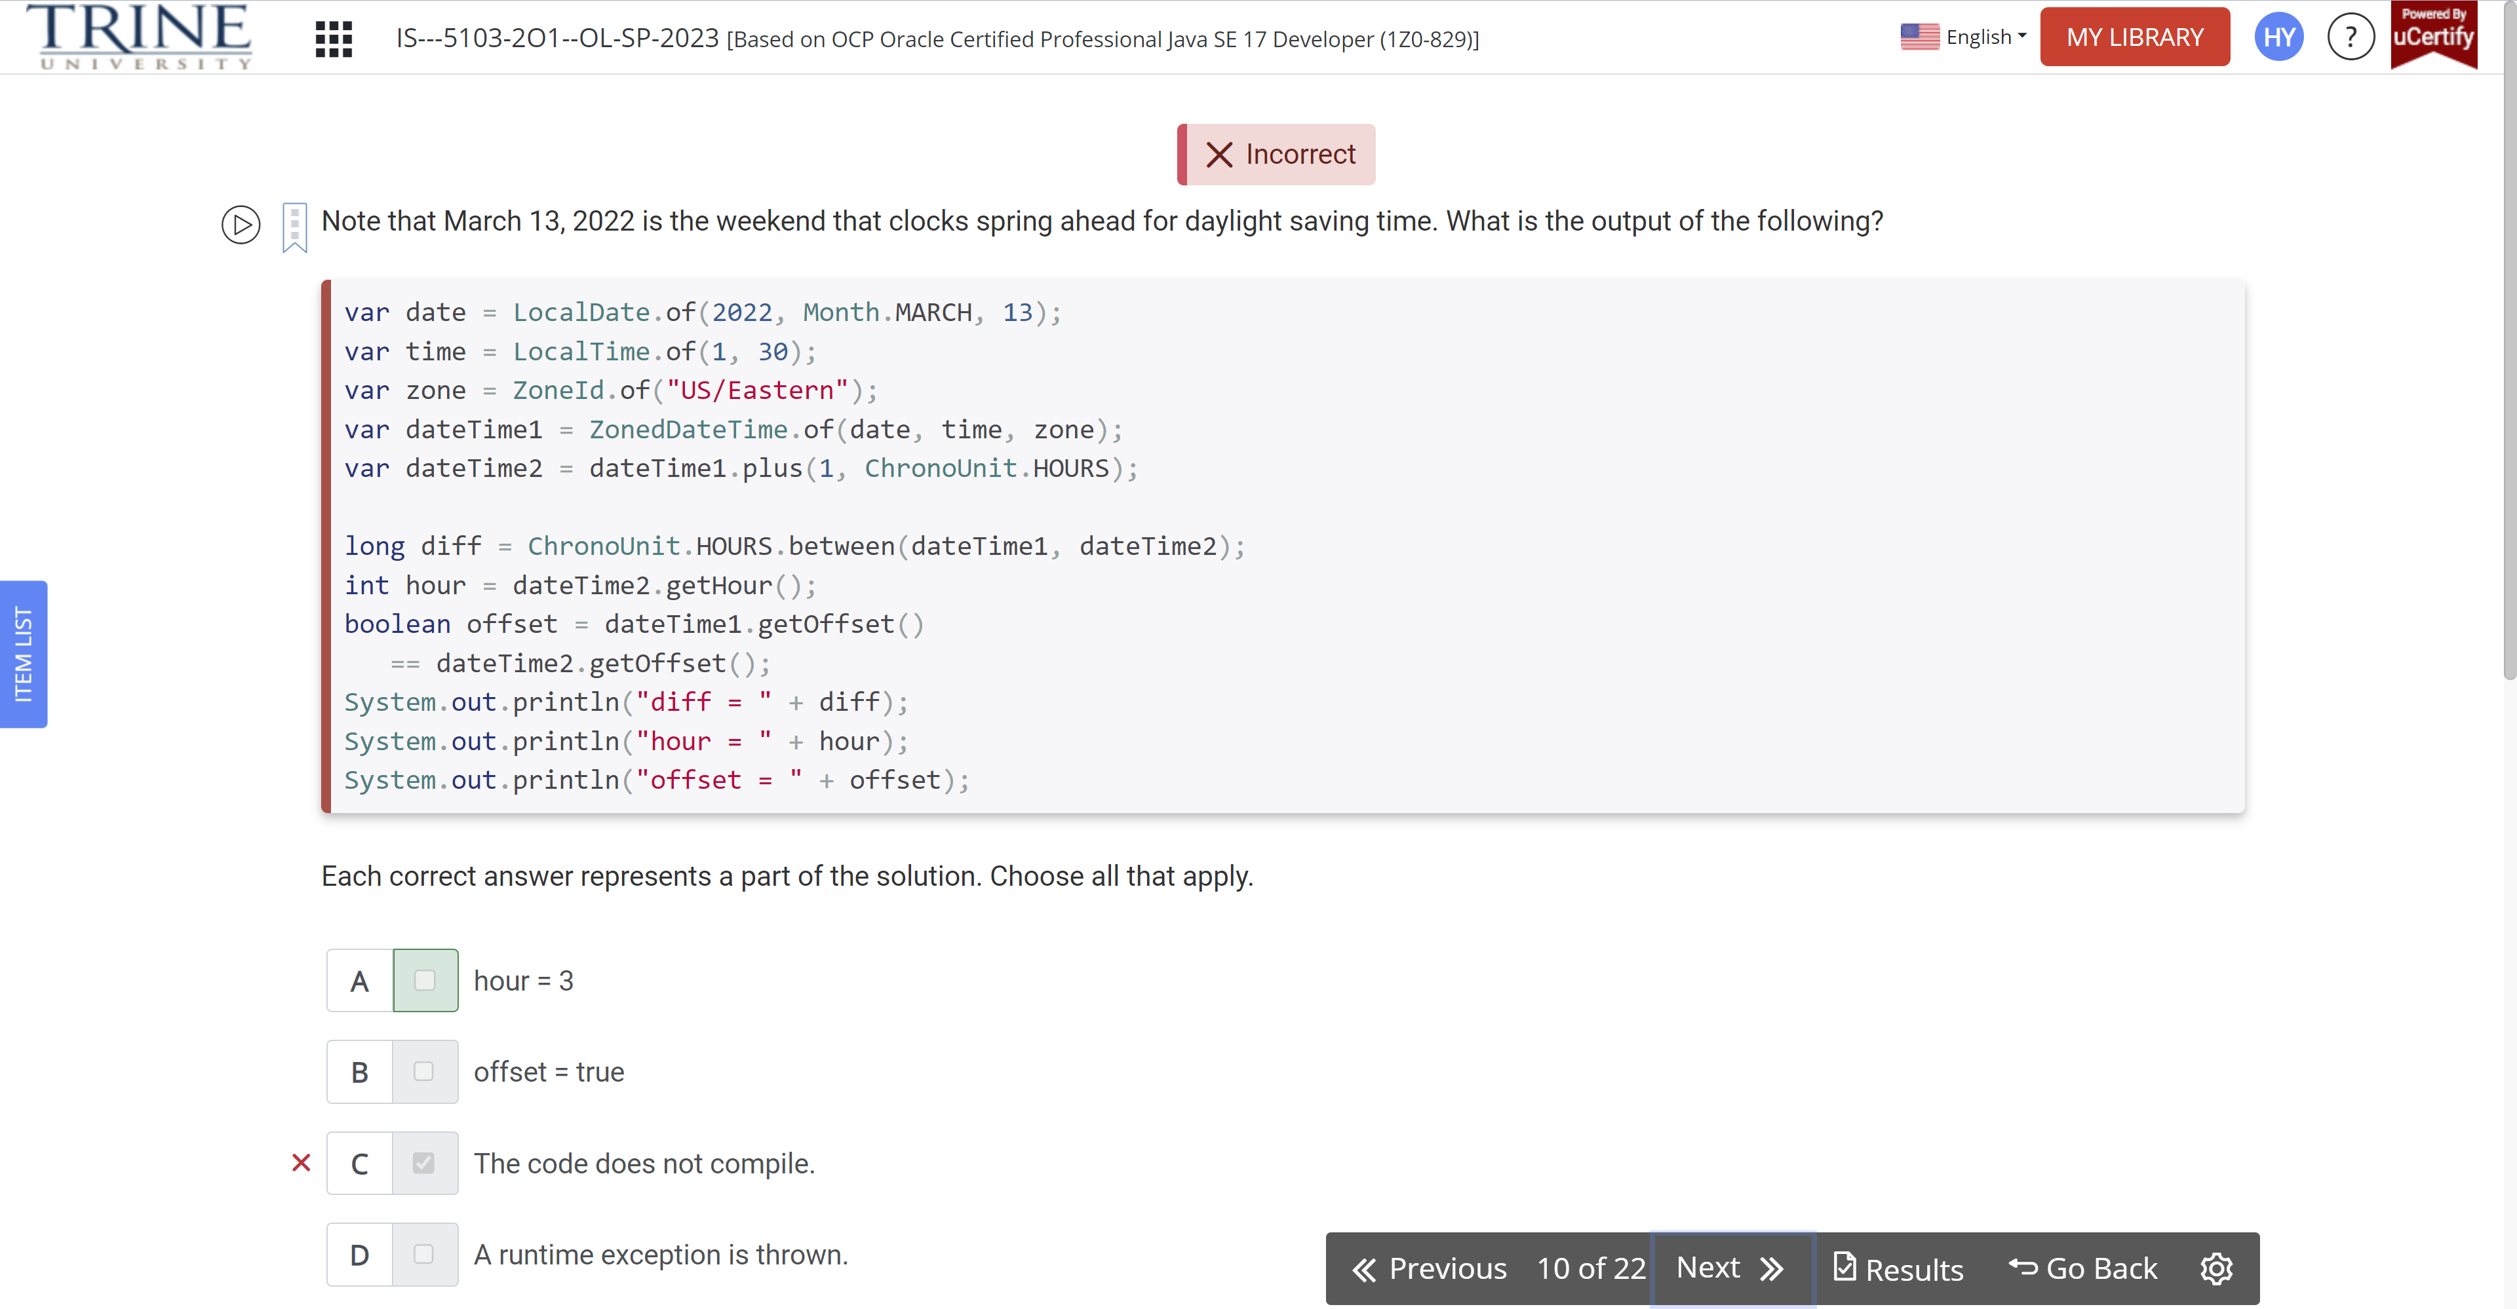

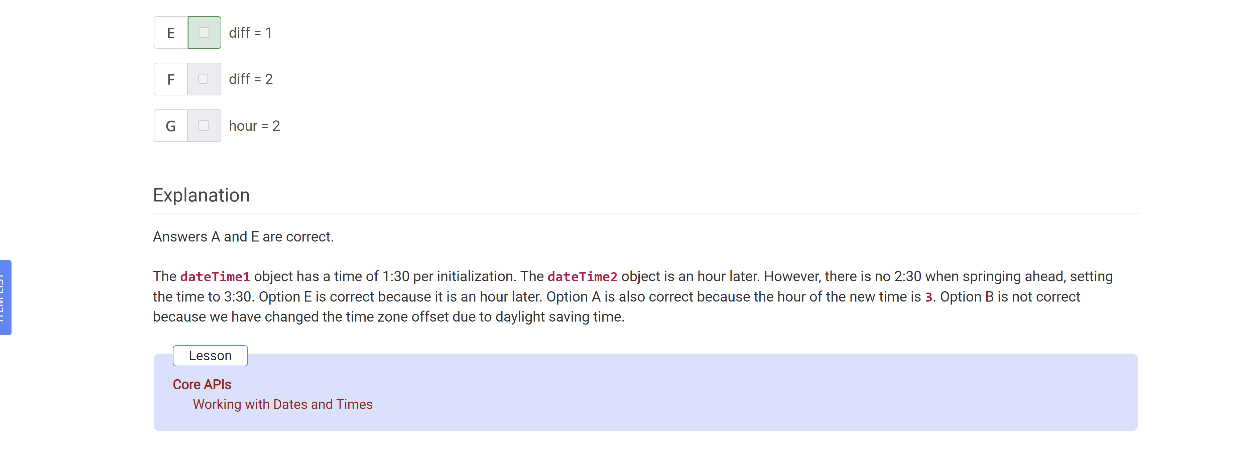

What is the result of the following code?

String s1 = “””

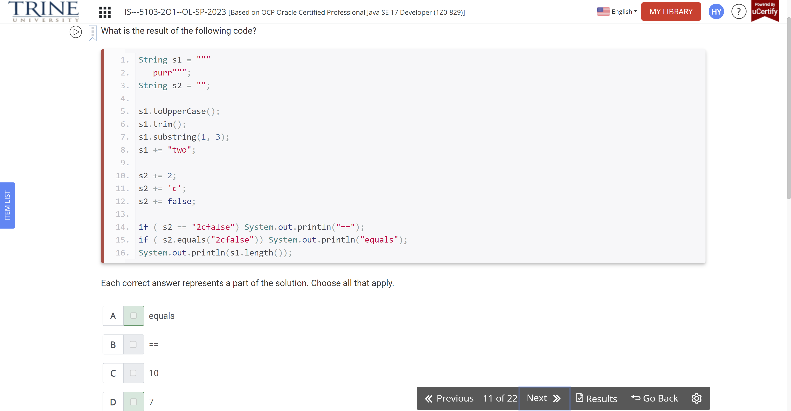

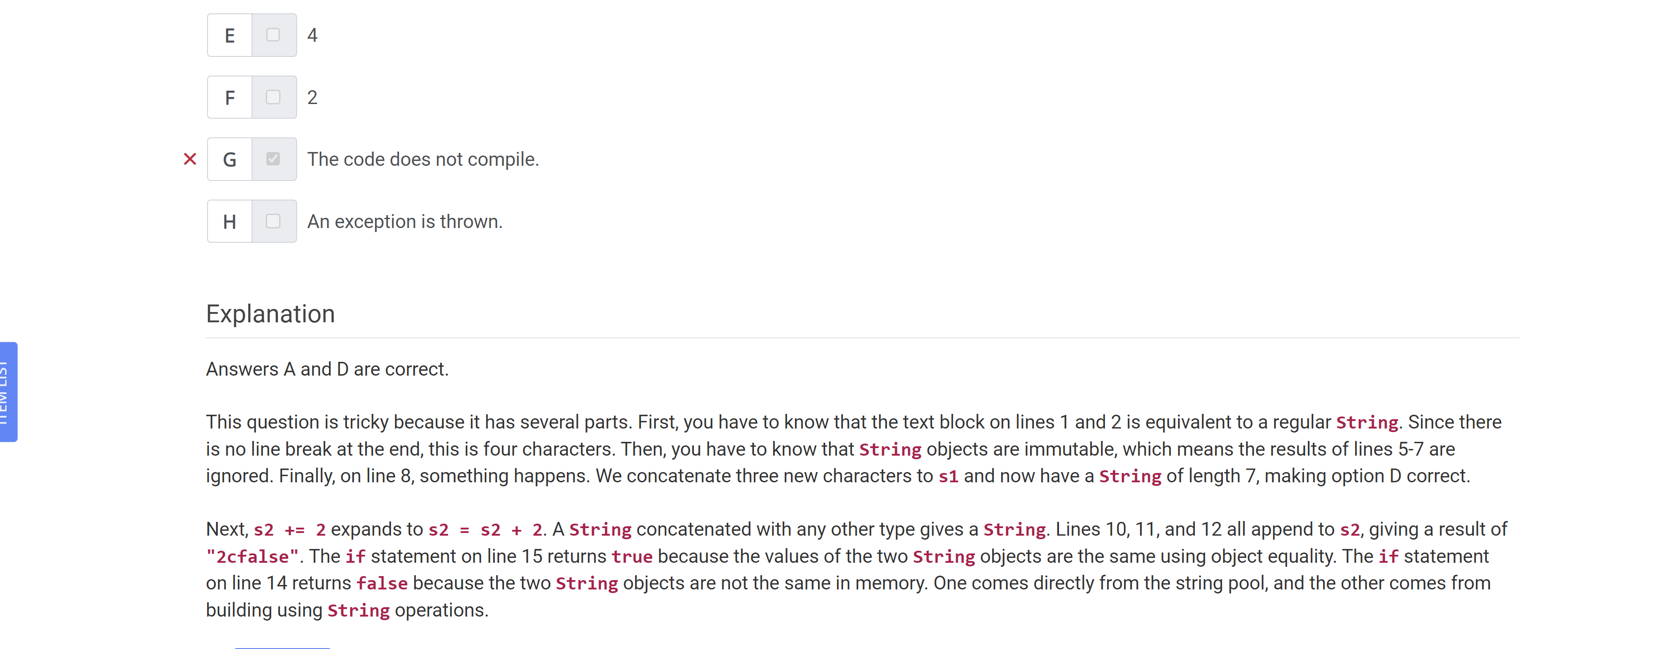

What is the output of the following code?

Var S = “hello”;

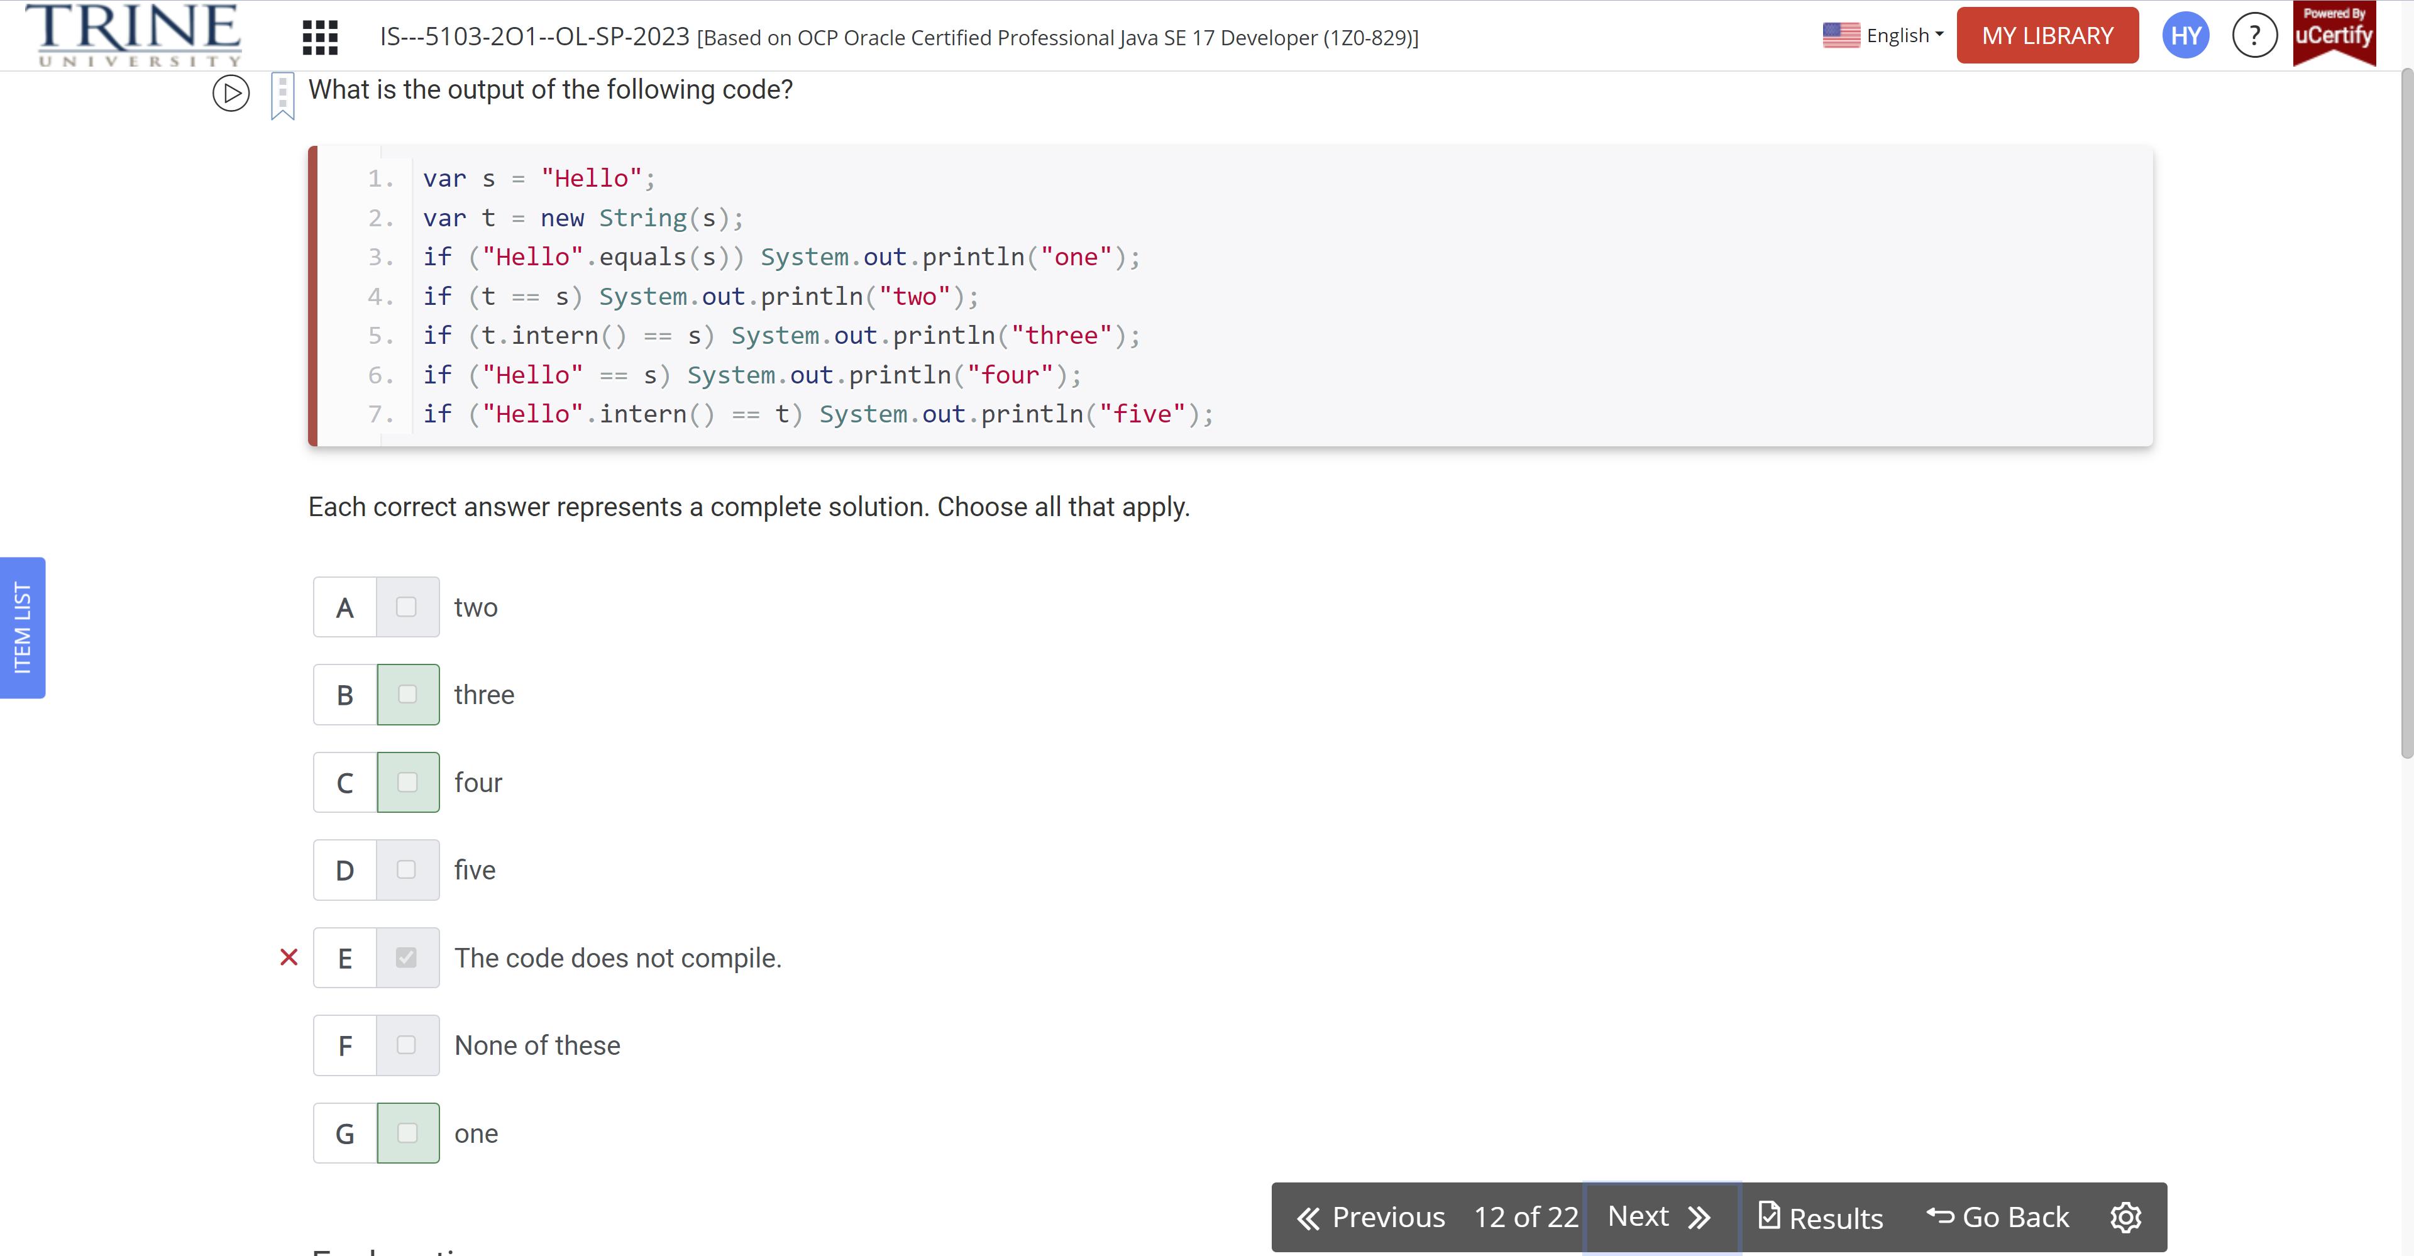

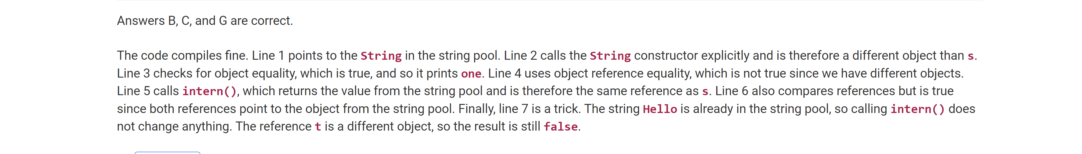

Which of the following are true about arrays?

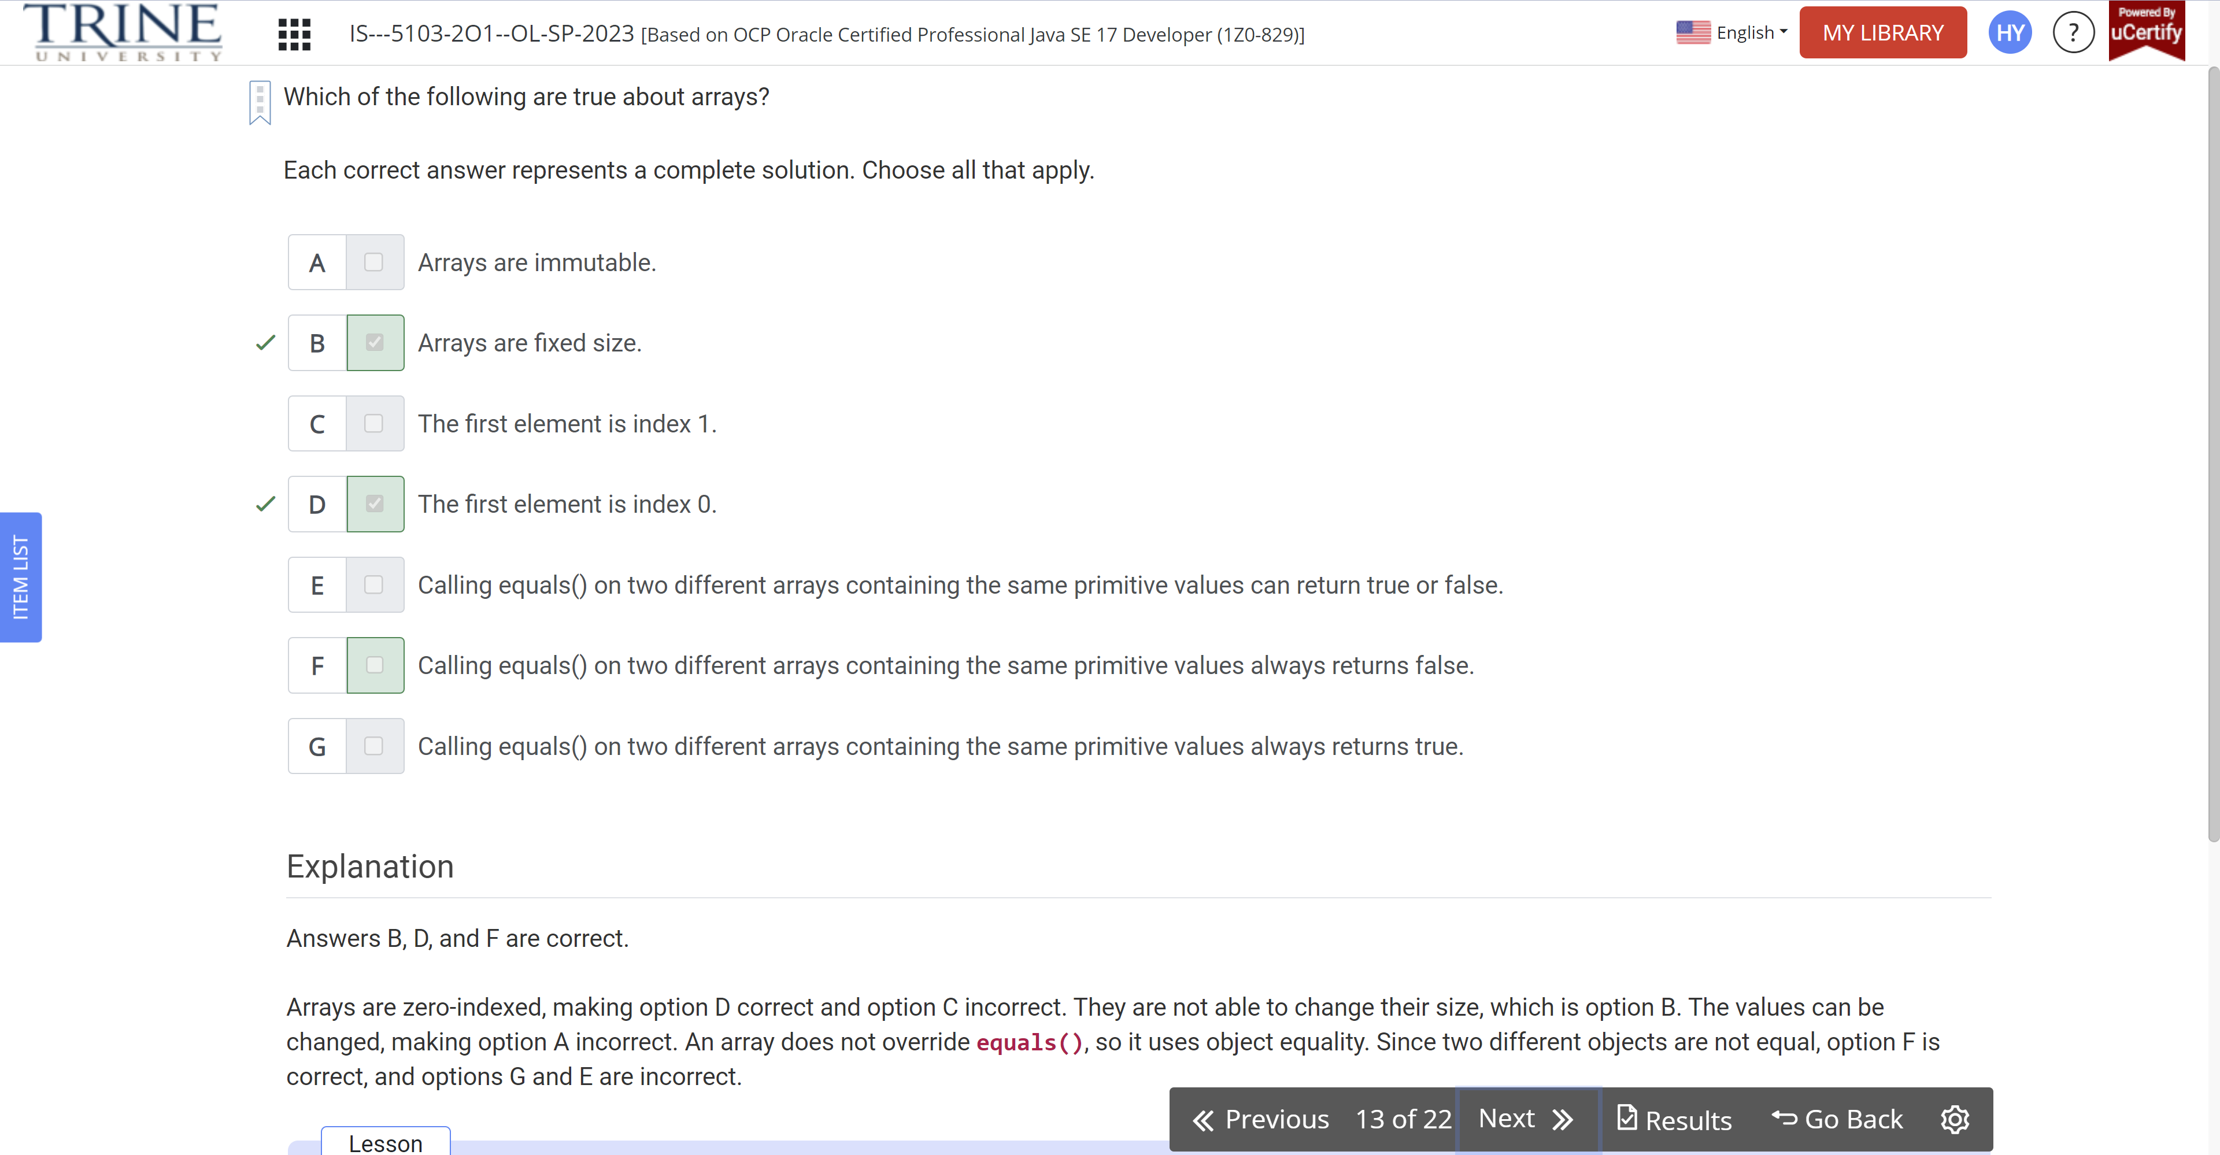

Which of the following can fill in the blank to print avaJ?

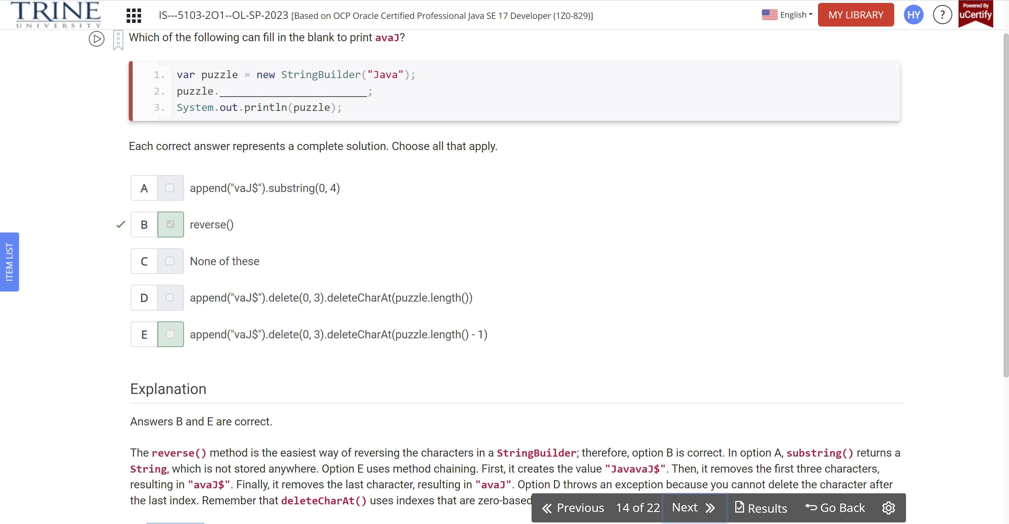

What is the output of the following code?

Var date = LocalDate.of(2022, …

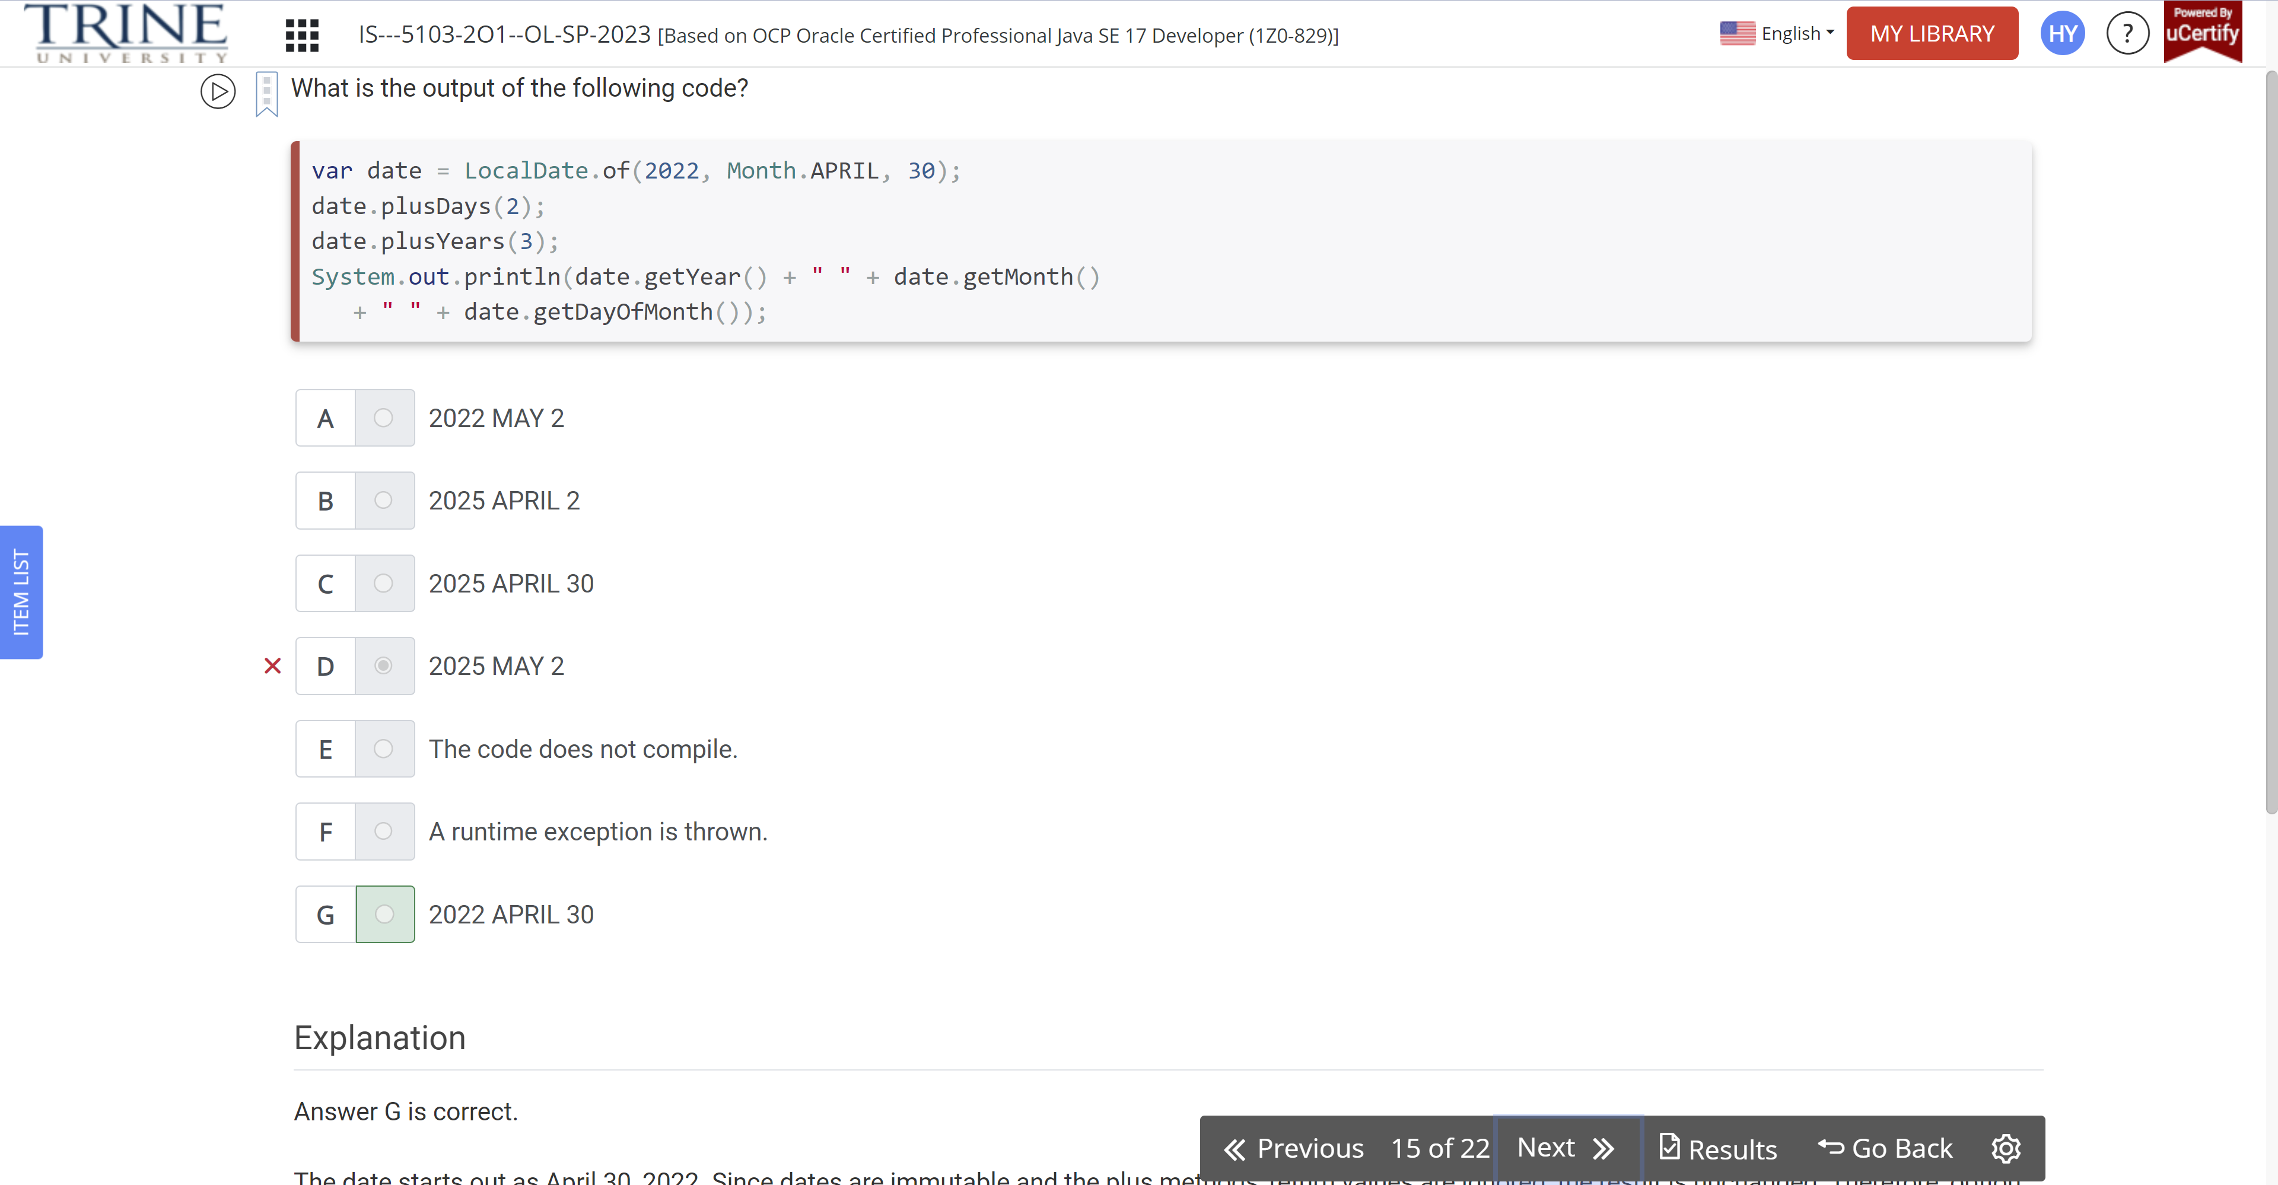

How many of these lines contain a compiler error?

Double one = …

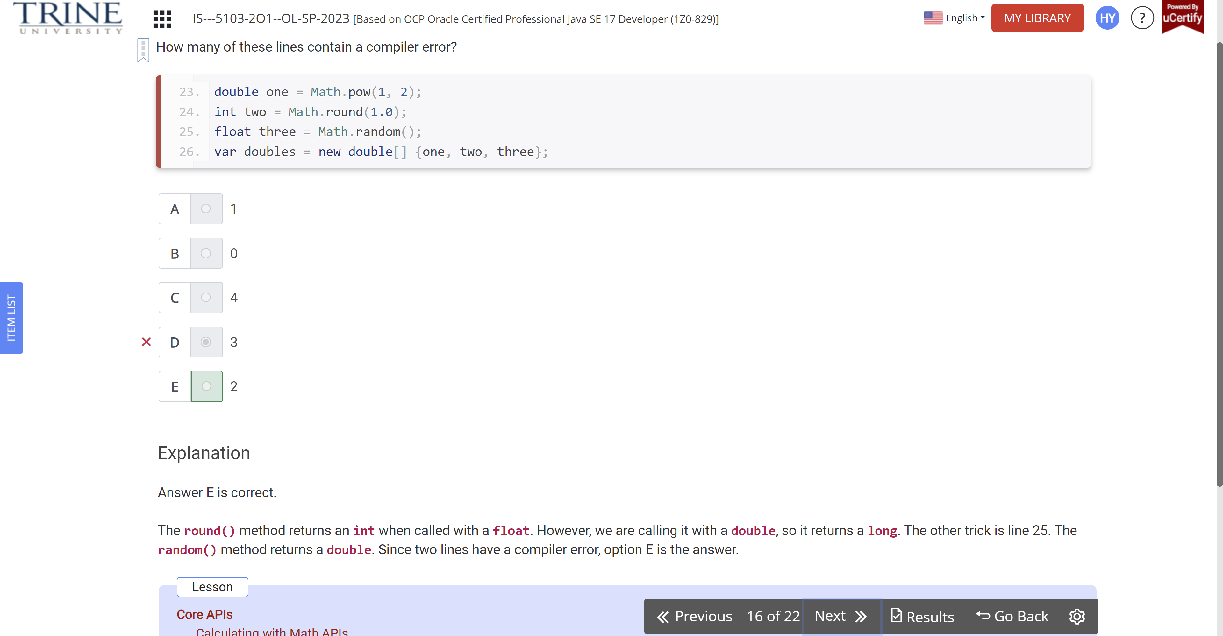

What is the output of the following?

Var arr = new String[] {…}

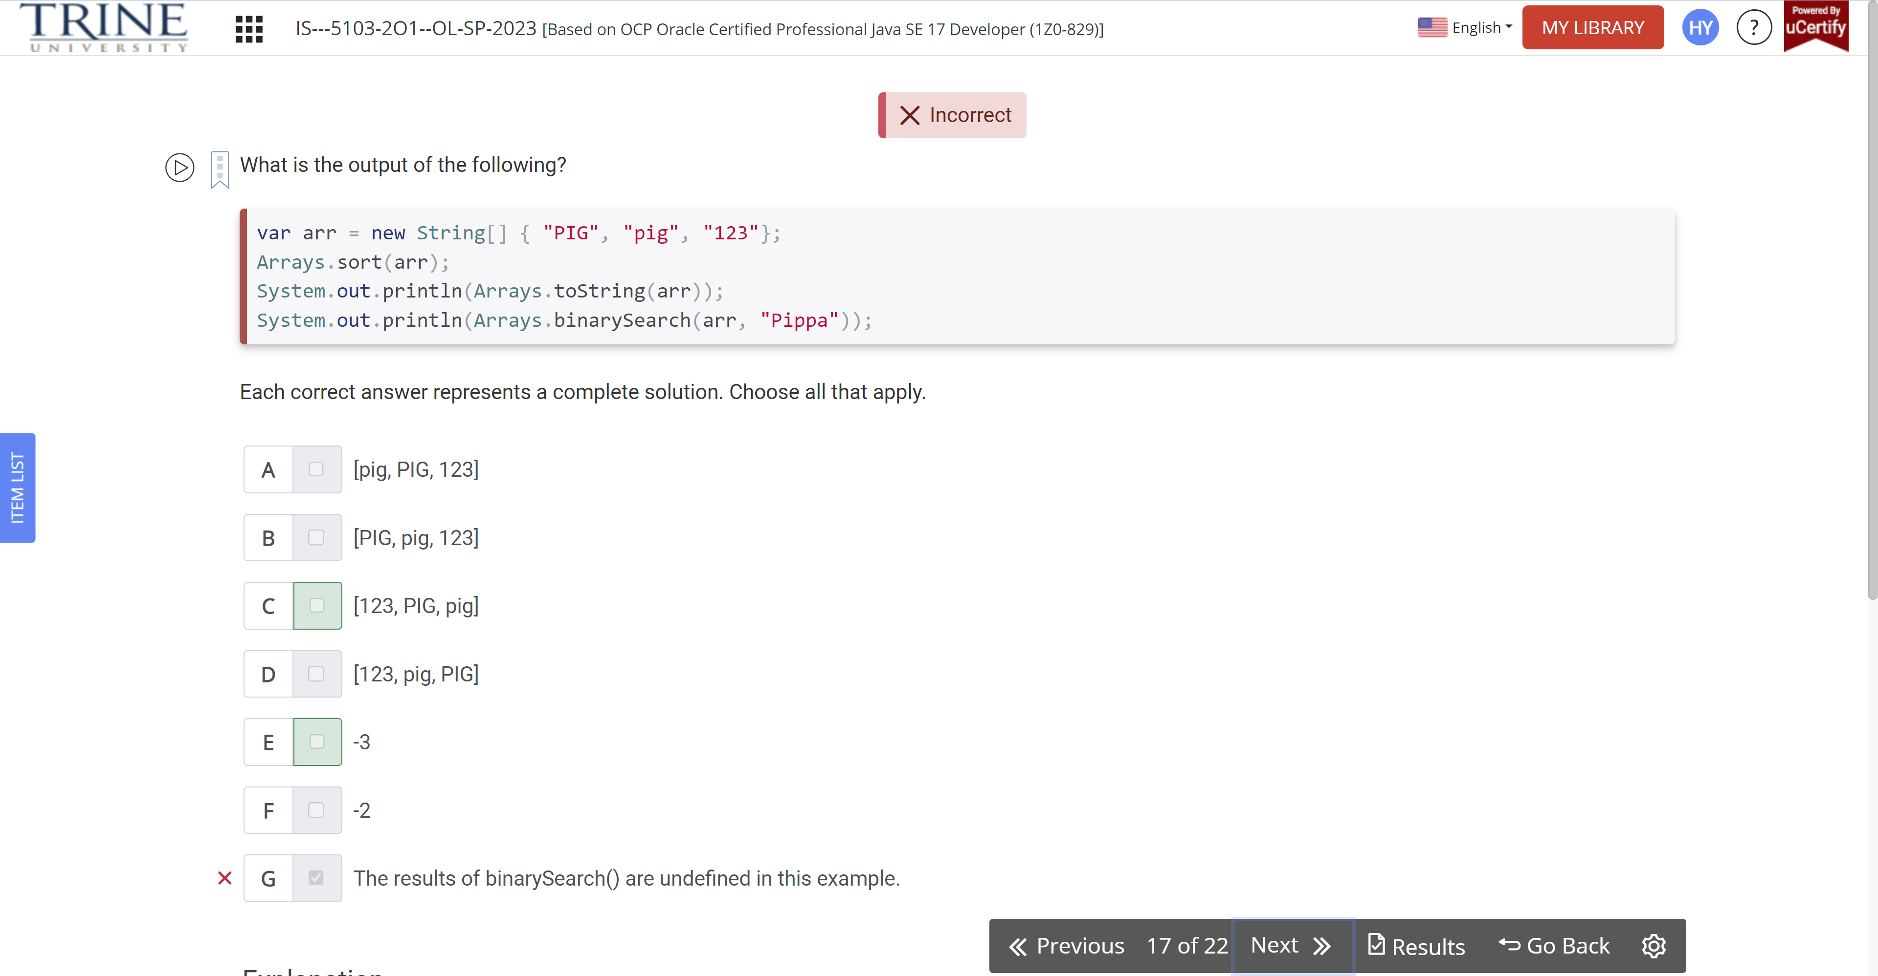

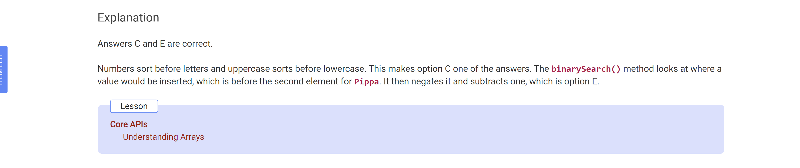

Which of these statements are true?

Var letters = new …

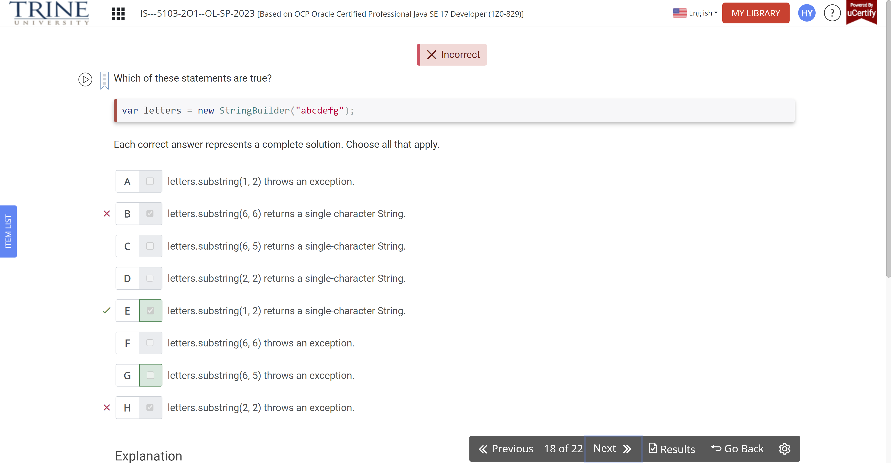

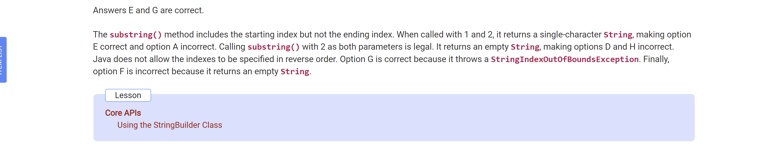

Which of these statements are true for the two values?

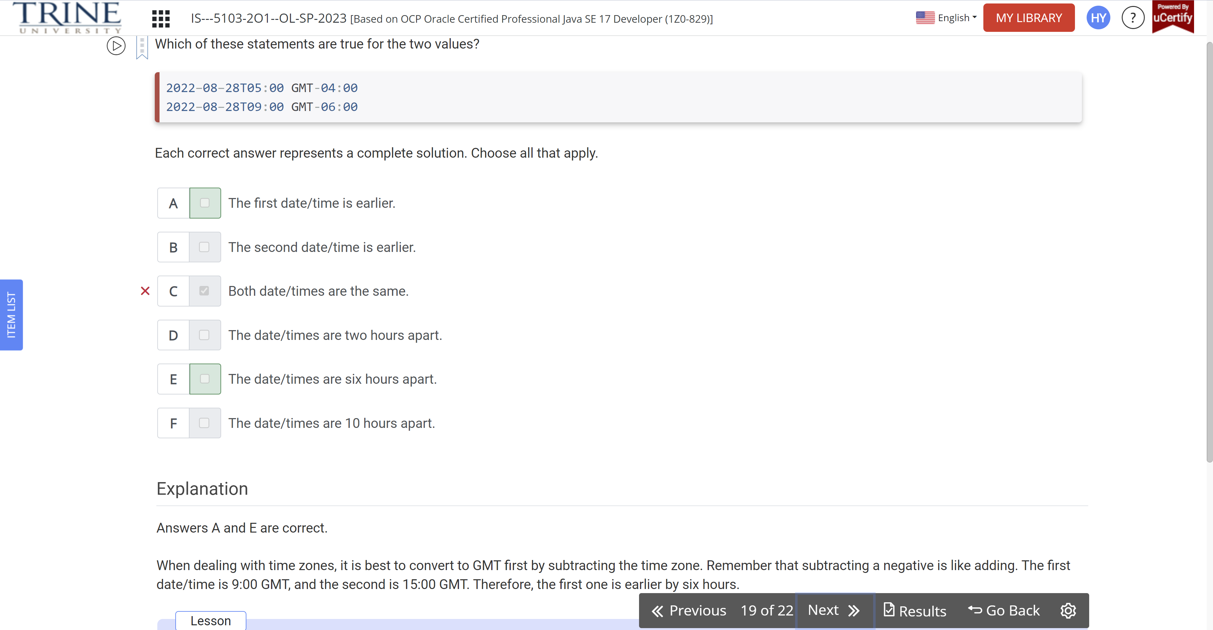

Given the following, which can ..

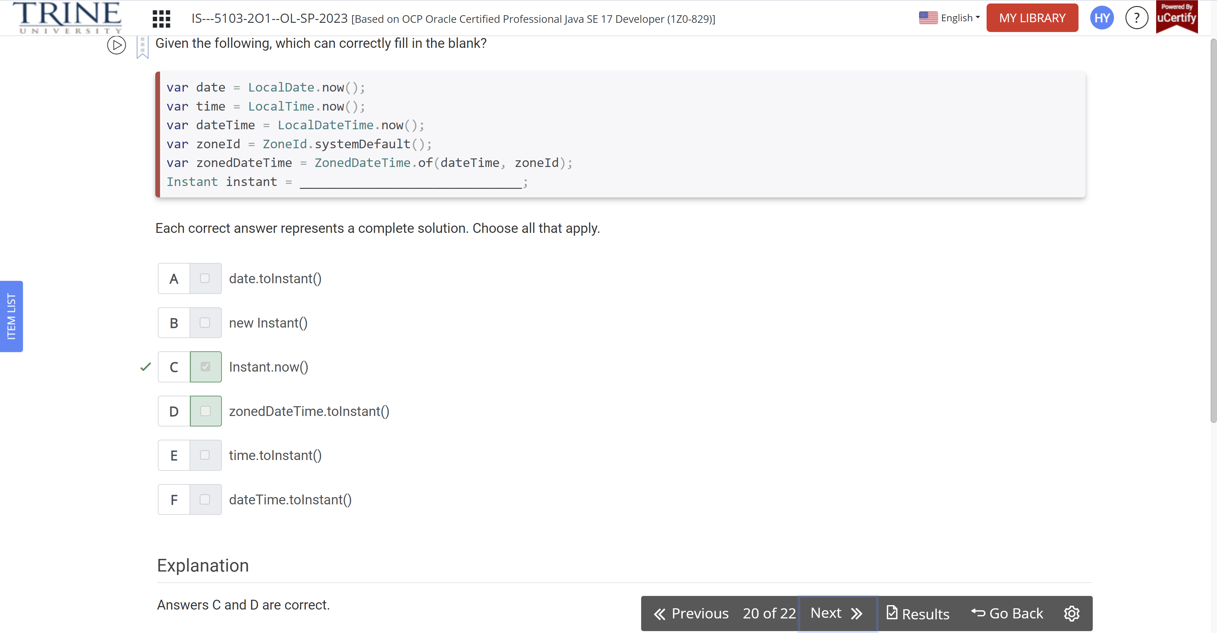

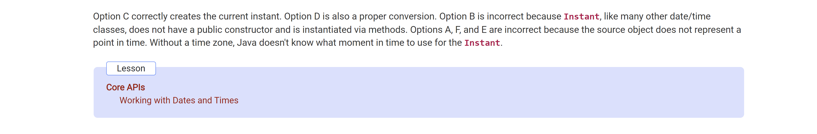

Which of the following fill in the blank to print a positive integer?

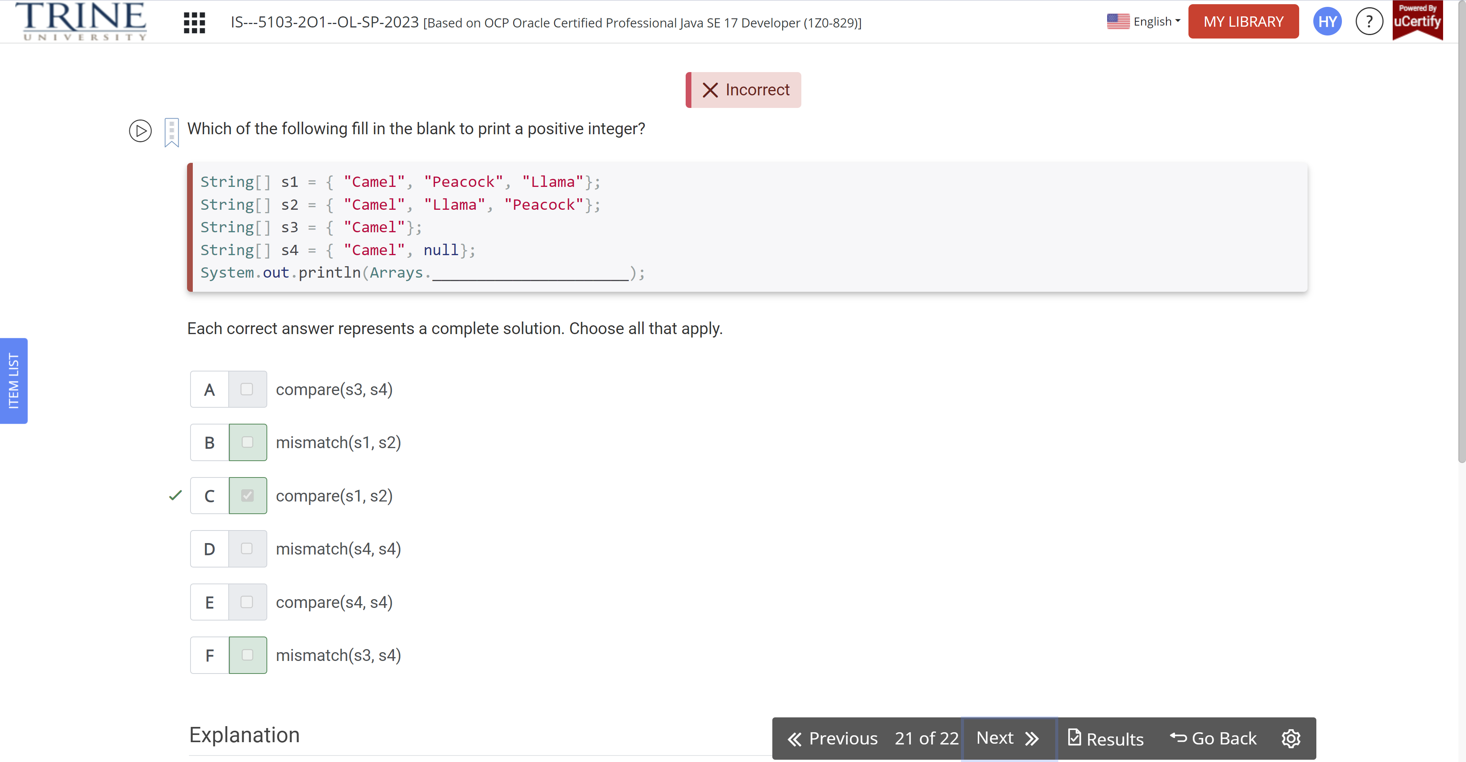

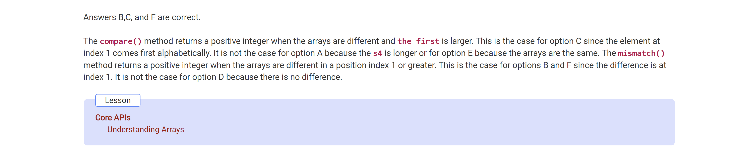

What is the result of the following code?

Public class Lion …

